**Culture| Back Story**

**文化|背景故事**

（英文部分选自经济学人202200611期文化版块）

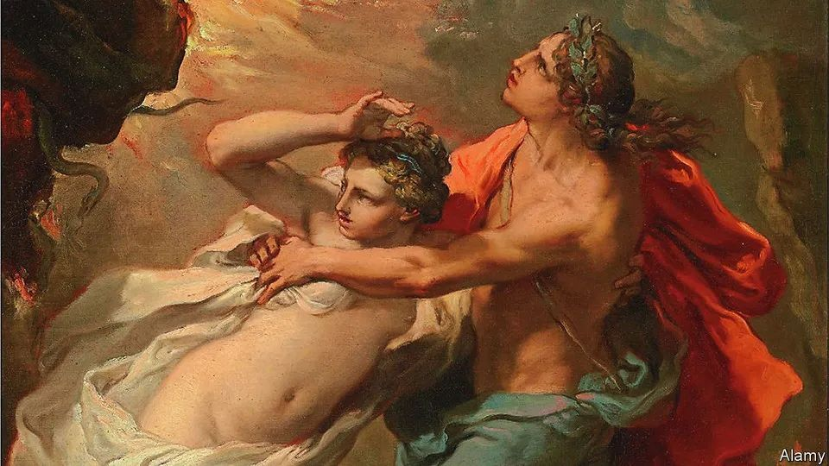

Visiting the scenes of stories is an act of imagination

游览故事中的实景地是一种想象行为

The true destination lies in the pilgrims’ mind

真正的目的地在朝圣书迷的脑海里

①As you approach the gateway to the underworld, the driving gets hairy. The clifftop road skirts ruined towers and terraces carved by desperate farmers into the barren mountains, before dead-ending at the southern tip of the Mani, the wildest part of the Peloponnese. The roar of the cicadas dies away and, on the finger of land dividing the Aegean and Ionian seas, only thorns seem to grow. Known as Cape Matapan or Cape Tenaro, this beautiful, desolate headland hosts the entrance to the kingdom of Hades.

驱车逼近冥界的大门，驾驶变得惊险起来。塔楼破败不堪，原本农民开垦的梯田已经沦为荒芜，令人绝望。周围便是崖顶的一条道路，通向摩尼半岛南端的尽头。而摩尼半岛则是伯罗奔尼撒最荒野的地区。蝉鸣渐渐消失了，狭长的土地将爱琴海和爱奥尼亚海分隔开来，这里似乎只有荆棘生长。这个荒无人烟的美丽海角名为马塔潘角或塔纳罗角，是通往冥府的入口。

②Or so classical authors such as Euripides implied; others put the gateway farther north in Greece, or near Naples, or on the Turkish coast. But for visitors who suspend disbelief on the path that winds from a derelict chapel to a quiet cove, this is it: the place where Heracles dragged Cerberus, the three-headed guard-dog, snarling into the light, and where Orpheus turned and lost Eurydice to the darkness for ever.

希腊古典时期的作家欧里庇得斯或许暗示过该海角是冥府入口；其他作家则将冥府入口设置在希腊的更北边，或者靠近那不勒斯，又或在土耳其海岸线某处。游客暂且把怀疑抛之脑后，走在荒废小教堂与寂静小海湾之间的蜿蜒道路上，对于这些游客而言，此处便是赫拉克勒斯把地狱三头犬刻耳柏洛斯拽到阳间的地方，也是俄耳甫斯救回欧律狄刻而欧律狄刻在黑暗中永远消失的地方。

③Classical landmarks drew sightseers even before Byron set off a craze for them 200 years ago. Boosted by screen adaptations, literary tourism has since become a mass pursuit, as the post-covid holiday rush attests. Harry Potter fans are again queuing to pose beneath the sign for Platform 9¾ at King’s Cross station, whence trains to Hogwarts depart in J.K. Rowling’s books. From the mortal platforms nearby, devotees can again unravel “The Da Vinci Code” on London-to-Paris tours. On June 16th, when the action of “Ulysses” is set, Dubliners will celebrate Bloomsday—named for James Joyce’s protagonist, Leopold Bloom—in the novel’s costumes and pubs.

200年前，拜伦曾引发过游客对古典著作地标的狂热，然而甚至在此之前人们就会游览文学地标。在荧幕改编的推动下，文学旅游自此成为一种大众热潮，疫情后假期的旅游热便证明了这一点。哈利波特粉再次在国王十字车站的9¾站台标志前排起长龙摆拍，这里是J.K.罗琳书中开往霍格华兹的火车起点站。附近的其他普通站台上，书迷们踏上从伦敦到巴黎的旅途，再次解读《达芬奇密码》。6月16日，也就是《尤利西斯》中情节发生的日子，都柏林人将庆祝以詹姆斯·乔伊斯书中主角奥波德·布鲁姆（Leopold Bloom）命名的“布鲁姆日”，人们会身着小说中的服装，到小说中的酒吧庆祝这一日子。注：6月16日是一年一度“布鲁姆日”（Bloomsday），旨在纪念20世纪爱尔兰小说家詹姆斯·乔伊斯巨著《尤利西斯》的诞生，6月16日是《尤利西斯》的主人公利奥波德·布鲁姆在爱尔兰街头游荡的日子。每年的这一天，世界上60多个国家的乔伊斯爱好者都会聚在一起，举行各种各样庆祝活动。

④A quarter of British travellers stop at bookish attractions on domestic trips, says a survey. On the face of it, the urge to follow in imaginary footsteps is odd, even irrational. Look more closely, and as well as private enthusiasms, these journeys trace the alchemical links between stories and their readers.

一项调查显示，四分之一的英国游客在国内旅行时乐于在“书中之地”驻足流连。从表面上看，这种追寻虚构场景的冲动相当古怪，甚至不合常理。倘若更仔细地探究，就会发现，除了游客自发的热情之外，这些旅行还能揭示出故事和读者间神秘奇妙的联系。

⑤It is one thing to visit the spots where authors wrote and died, trekking to the Brontë parsonage at Haworth or down the causeways to Hemingway’s bolthole in Key West. Seeking out the sites of fictional marriage proposals—or ancient myths—is weirder. After all, the characters, being made up, never went there; nor, sometimes, did the authors. More eccentric still are quests to find non-existent places like Tolkien’s Middle-earth. In “Confederates in the Attic”, Tony Horwitz described tourists in Georgia searching for Tara, home of Scarlett O’Hara, though the film of “Gone with the Wind” was mostly shot in California, and Margaret Mitchell, the book’s author, made sure her plantation resembled no real ones.

参观作家生前写作的地点和逝世地点也就罢了，比如徒步前往霍沃斯的勃朗特牧师住所，或者沿着堤坝前往海明威在基韦斯特的度假屋。与之相比，更奇怪的举动是去寻找那些虚构小说中的求婚地或古老神话发生地。毕竟，小说中的人物是虚构的，他们从未去过那里；有些地方甚至连作者也没去过。而更加荒诞古怪的行为是去寻找那些根本不存在的地方，比如托尔金的中土世界。托尼·霍维茨在《阁楼上的邦联》（Confederates in the Attic）描述道，曾有游客在乔治亚州寻找斯嘉丽·奥哈拉的家——塔拉庄园，尽管《乱世佳人》这部电影大部分是在加利福尼亚州拍摄的，《飘》的作者玛格丽特·米切尔也明确表示她所描绘的种植园与真实的种植园并不相像。

⑥Plainly, it is easy to be snooty about literary tourism. The yen to see and touch the scenery of books can seem ploddingly literal. In their heads, it is said, everyone is the hero of their own story, but lots of people seem content to be an extra in someone else’s. Missions to track down invented figures or settings seem bound to end in disappointment—except for the entrepreneurs and marketeers who peddle Sherlock Holmes deerstalkers or guides to Jane Austen’s Bath.

很显然，对这种“文学旅游”冷嘲热讽很容易，但想去亲自参观和触碰书中场景的愿望可能只是好梦难圆。有人说，在人们的脑海中，每个人都是自己世界的主角，然而对许多人而言，似乎能成为别人故事中的一个角色就已经足够了。追寻虚构人物或场景的计划似乎注定要以失望告终，除了那些企业家和营销人员——他们靠兜售福尔摩斯戴的猎鹿帽或吸引游客去简·奥斯丁待过的巴斯旅游来从中渔利。

⑦The elusiveness, however, may be the point: the true destination lies in the pilgrims’ imagination. Influenced by post-structuralism, a school of criticism has from the 1960s analysed fiction in a related way, as a collaboration not a sermon. Authors, in this view, do not have godlike power to fix a work’s meaning; readers are not passive recipients but partners in creation. Barbara Schaff, an expert on literary tourists at the University of Göttingen, sees them as collaborators in “The Death of the Author” (the title of a famous essay of 1967 by Roland Barthes). The Harry Potter luggage trolley embedded in the wall at King’s Cross is, she says, “material testimony” to “the reader’s power to create the text”.

也许，难以找寻书中场景才是关键所在，毕竟真正的目的地在朝圣书迷的脑海里。受后结构主义影响，一派文学批评家自上世纪60年代起以一种关联法分析文学作品，将解读文学作品视为一种协作，而非作者的一言堂。该学派认为，作者并不具有主宰作品内涵外延的绝对力量，读者也参与了作品的创造过程，而非只是被动接纳书中所述。哥廷根大学的芭芭拉·沙夫（Barbara Schaff）是文学旅游领域的专家，在她看来，文学旅游的游客也共同参与到作品的创作，这促成了“作者之死”（借用罗兰·巴特1967年发表的著名文章标题）。她认为，国王十字火车站里嵌入墙体的哈利波特行李推车，正是支持“读者具有创造文本能力”这一观点的“重要证据”。

⑧Perhaps. Another way to put it is that, for many, fiction can seem more vivid than life. Visiting the scene of a story is a means to revive its drama and resurrect its characters, freeing them from the dead, finite bounds of a book. It is a bid to expand the borders of the actual world to take in another one. It is a magic trick against reality.

事实可能的确如此。换言之，在许多读者眼中，小说似乎比现实更鲜活。读者通过游历某部小说的实景地，想象书中情节在此重新上演，书中人物也冲破纸张的冰冷桎梏，跃然现于眼前。这都是为了拓展现实世界的边界，以吸纳虚构世界，就好像是对现实变了个戏法。

⑨In his travelogue of the Mani, Sir Patrick Leigh Fermor placed the portal to the underworld in a phosphorescent cavern along the coast from the headland. No matter. In the cove at Cape Tenaro, hidden by an eerie burst of foliage, is a cave with an overhanging lip that suggests a giant maw. Inside is a stagnant pool and, at the back, an icky-looking recess. In the murk it is hard to see how deep it goes. Maybe all the way.

在为摩尼半岛写的游记中，帕特里克·莱斯·弗莫尔爵士（Sir Patrick Leigh Fermor）将冥府入口设置在岬角海岸旁一个泛着磷光的洞穴中。这不重要。在塔纳罗角海湾，森然可怖的密林中隐藏着一处洞穴，洞口高悬，可知此洞颇深。入洞遂见一处死水潭，潭后是个阴湿渗人的凹穴。此中昏暗，看不真切，不知深几许。许是个万丈深渊。